TradeDesk-AI — Build plan
Four people, four lanes, five phases. Most of the app is built on the mock broker before kickoff; the hackathon itself is for the real 021 API, hardening and the demo.

Team roles
Each person owns one lane end to end. Swap names into the first column.
Person | Lane | Owns | Main files
A | Frontend | Every screen: chat, account panel, order and plan cards, rules list, chaos panel, cost card, audit timeline | frontend/src/components/*, src/lib/api.ts, ws.ts
B | Orders and safety | Pydantic schemas, approval hash and expiry, price-drift re-quote, executor with idempotency, hard limits, charges calculator, Anchor/Buffett/Co-Captain checks, audit log | app/schemas.py, app/orders/*, app/safety/*, app/audit/*
C | LLM | Orchestrator loop, read-only tools, propose-order and propose-plan tools, system prompt, ambiguity handling, injection guard | app/llm/*
D | Broker and rules | BrokerAdapter interface, mock broker with tick simulator, real 021 adapter, rules engine (fire-once, restart recovery), chaos endpoints, tests | app/broker/*, app/rules/*, tests/*
Shared, decided together in Phase 0: schemas.py (B leads) and the REST + WebSocket contract (A and B lead).

Roadmap
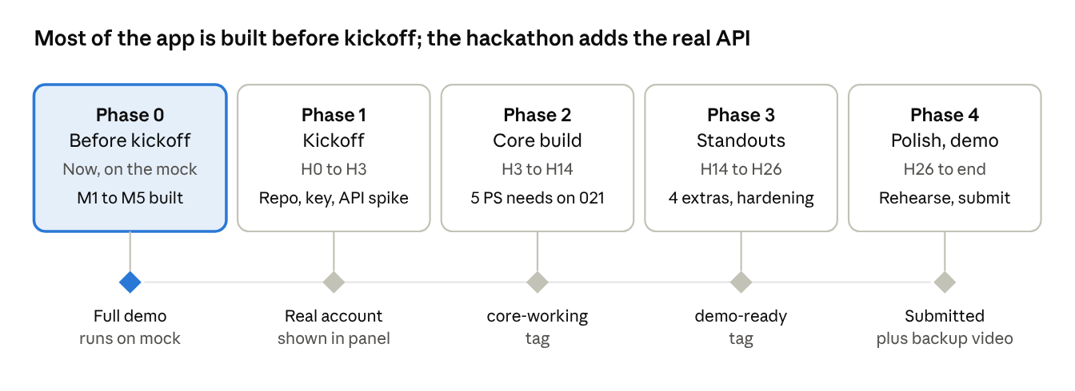
build roadmap · 5 phases, each with an exit gate
Hours count from the hackathon start (H0). Each diamond is an exit gate: don't start the next phase until it passes.

Phase 0 — Now, before kickoff
Goal: milestones M1–M5 running end to end on the mock broker. Work in a shared local folder (Drive, zip or Live Share). No git init, no commits until the hackathon starts.
Together (first session, about 2 hours)
- ☐ Lock decisions: LLM provider and API key, equity-only or equity + F&O, approval expiry (60 s), drift limit (1%), hard limits
- ☐ Write schemas.py: OrderIntent, PendingOrder, Plan, Rule, Holding, Position, Order, Quote, Tick (money in integer paise)
- ☐ Agree the REST + WebSocket contract (endpoint list in the main tab)
- ☐ Write the BrokerAdapter interface (method list only)
- ☐ Wireframe the 4 screens on paper or Figma
A — Frontend
- ☐ React + Vite + Tailwind + shadcn/ui setup
- ☐ Chat UI, account panel, order card, plan card against hard-coded JSON
- ☐ Rules list, cost-card layout, chaos panel buttons
- ☐ Wire to the mock backend (REST + WebSocket)
- ☐ Order card shows validity (Day / IOC / Minutes) and all 8 charge items
- ☐ Multi-step plans labelled "basket order" in the UI
B — Orders and safety
- ☐ Approval service: hash, 60 s expiry, price-drift re-quote, protected limit for market orders
- ☐ Executor: client order ID, write-ahead record, no blind retry, reconcile on startup
- ☐ Hard limits, charges and break-even calculator
- ☐ Anchor, Buffett Mode and Co-Captain states and checks; audit log table
- ☐ 021's hard limits: max 1,00,000 units and ₹1 crore per order; limit price inside the day's price band; block when market closed or stock suspended
- ☐ validity field (Day, IOC, Minutes) in the order schema
- ☐ Charges calculator covers all 8 parts: brokerage, STT, exchange, SEBI, stamp duty, GST, clearing, investor protection fund
- ☐ Anchor blocks new orders only; read-only queries keep working
C — LLM
- ☐ Orchestrator loop with function calling
- ☐ Read-only tools: funds, holdings, positions, orders, quote, option chain
- ☐ propose_order and propose_plan tools that only create drafts
- ☐ System prompt, ambiguity handling ("Tata Motors or Tata Steel?"), injection guard
- ☐ Plain-English explanation for each 021 rejection reason (funds, price band, quantity, market closed, suspended, KYC)
- ☐ Buffett Mode answers: invested amount and long-term return, no daily P&L
D — Broker and rules
- ☐ Mock broker: seed account, tick simulator, partial fills, rejections
- ☐ Rules engine: tick dedupe, fire-once update, restart recovery
- ☐ Chaos endpoints: kill, drop network, duplicate ticks, forced reject
- ☐ Tests: fire-once, stale approval, duplicate order on timeout, injection
Exit gate: a full demo run on the mock (query → order → rule → plan → chaos) works without anyone touching code.

Phase 1 — Kickoff (H0–H3)
Goal: code in the coordinators' repo, the 021 key working, and one real call per data type.
Together (first 30 min)
- ☐ Clone the coordinators' repo; commit .gitignore and .env.example first
- ☐ Put the 021 key in .env only; never in code, chat, or the LLM's context
- ☐ Ask the 021 team the kickoff questions (main tab, section 5); top priority: API docs and whether the sandbox moves prices outside market hours
- ☐ Also ask: GTT Plus and basket orders via API? IOC/Minutes validity? Exits allowed under Anchor? Do API standing instructions need a SEBI algo ID?
- ☐ If GTT Plus is supported, D routes price-triggered orders to it; our rules engine keeps alerts
A — Commit the frontend in pieces (add chat UI, add order card, …); point it at the backend running locally.
B — Commit schemas, approval service and executor in pieces. Map 021's order statuses and error codes onto ours once D shares them.
C — Commit the LLM module. Run the full read-only query set against the mock to confirm nothing broke in the move.
D — 021 API spike
- ☐ Auth works, key loads from .env
- ☐ Fetch funds, holdings, positions, orders; get one quote; open the price stream
- ☐ Place, modify and cancel one tiny sandbox order
- ☐ Write API_NOTES.md: response shapes, order statuses, error codes, rate limits, order-ID/tag support
Exit gate: BROKER=zerotwoone shows the real account in the panel; BROKER=mock still runs the full demo.

Phase 2 — Core build (H3–H14)
Goal: all five PS requirements working on the real 021 sandbox, in this order: queries, single orders, standing instructions, plans.
A — Frontend
- ☐ Live order status on cards (pending → filled / partial / rejected)
- ☐ Re-quote state: amber card, "price moved, re-confirm"
- ☐ Plan outcome report view; rules list with edit/delete
- ☐ Clear error and loading states everywhere
B — Orders and safety
- ☐ Executor sends to 021; unique order ID or tag per order
- ☐ Timeout path: check the order book before any retry
- ☐ Modify and cancel through the approval flow
- ☐ Plan executor with per-leg results
C — LLM
- ☐ Re-test every query against real data shapes; fix wrong symbol matches
- ☐ Option chain on real instruments
- ☐ Plan proposals for multi-order requests
D — Broker and rules
- ☐ Real price stream into the rules engine
- ☐ Instrument lookup (symbols, lot sizes, tick sizes)
- ☐ Reconcile on startup: compare our orders with 021's order book
- ☐ Move the tests to run against both adapters
Exit gate (H14): on the real sandbox, a query, a single order, a standing instruction that survives a restart, and a two-leg plan all work. Tag the commit core-working.

Phase 3 — Standouts and hardening (H14–H26)
Goal: the four standout features demo cleanly, and the edge cases judges will try are handled.
A — Frontend
- ☐ Cost card with full charges and break-even price
- ☐ Anchor lock screen with the trader's own message; Buffett Mode view; Co-Captain approval screen
- ☐ Chaos panel wired to D's endpoints; "suspicious content" badge
- ☐ Audit timeline and export
B — Orders and safety
- ☐ Charges from 021's published pricing; check against one real fill
- ☐ Co-Captain co-approval above the trader's limit
- ☐ Discipline nudges if time allows (trade count, re-buy after loss, margin use)
C — LLM
- ☐ Red-team the copilot: 15–20 nasty prompts (injection, vague requests, "buy everything", mixed languages)
- ☐ Fix every failure in code or prompt; save the list as a regression test
D — Broker and rules
- ☐ Poisoned instrument in the mock for the injection demo
- ☐ Chaos scenarios proven: restart, network drop mid-order, duplicate ticks, forced reject
- ☐ "Demo mode" switch back to the mock in case the API or wifi fails
Exit gate (H26): the whole demo script runs twice in a row with no fixes in between. Tag demo-ready.

Phase 4 — Polish and demo (H26–end)
Goal: a calm, rehearsed demo and a team that can answer any "how does X work?" question. No new features after H26.
- ☐ A: UI polish, empty states, mobile check, pitch slides (problem, architecture, safety story, demo, what's next)
- ☐ B: Bug fixes only; prepare the viva answers on approval hash, idempotency and re-quote
- ☐ C: Freeze prompts; final red-team pass; prepare the viva answer on injection defence
- ☐ D: README with setup steps; final test run on both adapters; prepare the viva answer on fire-once and restart recovery
- ☐ All: record a backup demo video around H28
- ☐ All: rehearse the 5-minute demo at least 3 times, one person driving and one narrating
- ☐ All: each person can explain one safety mechanism end to end
Exit gate: submission pushed, video saved, demo rehearsed.

Working rules
- Sync every 3–4 hours, 10 minutes: done, blocked, next. Move unfinished tasks; don't extend a phase.
- Contract changes need both sides. Anyone changing schemas.py or an endpoint tells A and B first.
- Branch per person, merge to main only when it runs. Tag working states so you can roll back before the demo.
- Handoffs: D shares API_NOTES.md by H3; B shares the approval API by end of Phase 0; C shares the tool list by end of Phase 0.
- Cut, don't slip. If a phase runs late, drop in this order: discipline nudges, Co-Captain screen, option-chain extras, modify order, extra chaos buttons.
- Keys stay in .env. Only the broker adapter reads them; one person places test orders at a time on the shared account.

